user GUide

By Tsepo ndebele

Contents

**How to play the game** 2

**Classes and worlds** 2

**Players movement** 3

**Enemy movement** 3

**Collectables** 3

**Obstruction** 4

**Screens** 4

# **How to play the game**

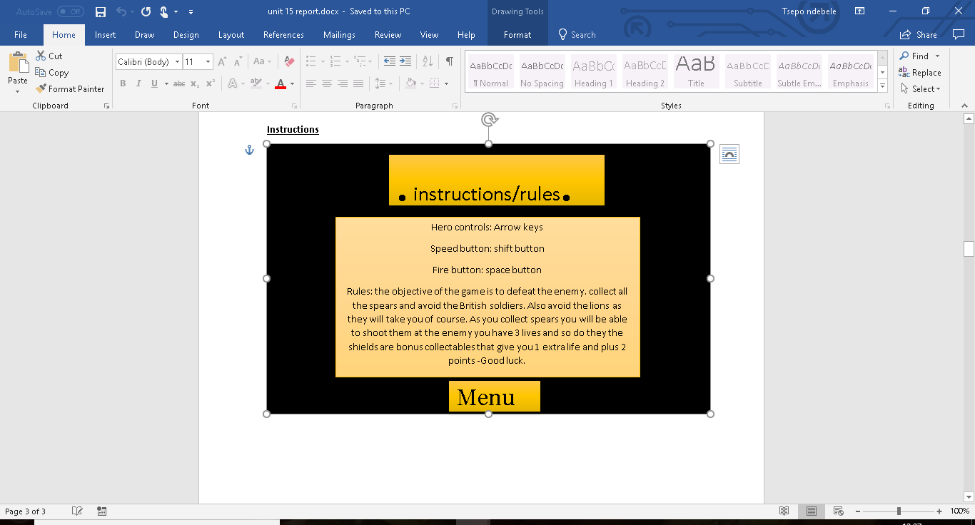

# **Classes and worlds**

ZULU player-turtle Class

Enemy-snake class

Spear-lettuce class

Throwing knife- projectile class

Lion-obstruction class

Shield- shield class

Main game screen-TurtleWorld

Help screen-HelpScreen

Menu-StartScreen

# **Players movement**

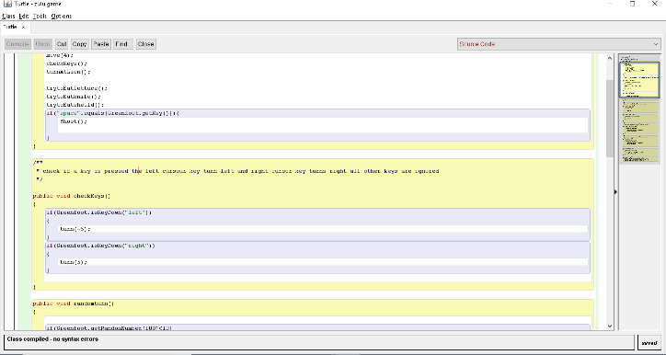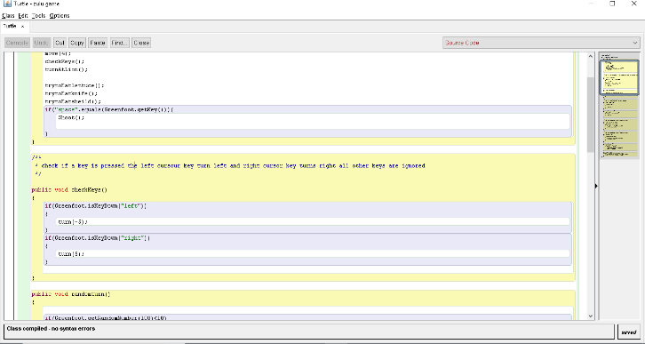

If you wan to edit the general movement of the player in would be in the turtle class. You can change the move speed and you can also change the keys for turning.

# **Enemy movement**

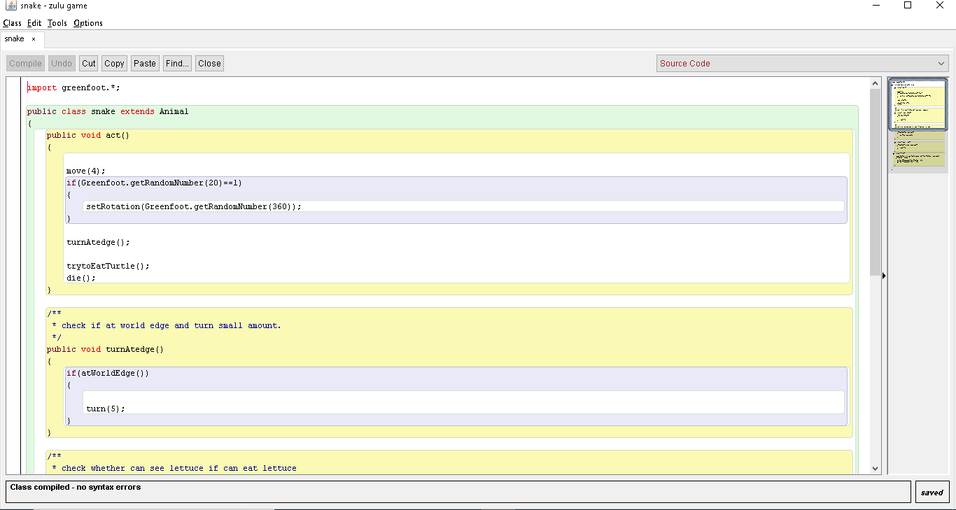

This were you can control the movement of the enemy now it’s at set to randomly turn but you are able to change the speed of how much it turns and if you wanted to you could make them player able by adding key inputs.

# Image result for zulu iklwa spear**Collectables**

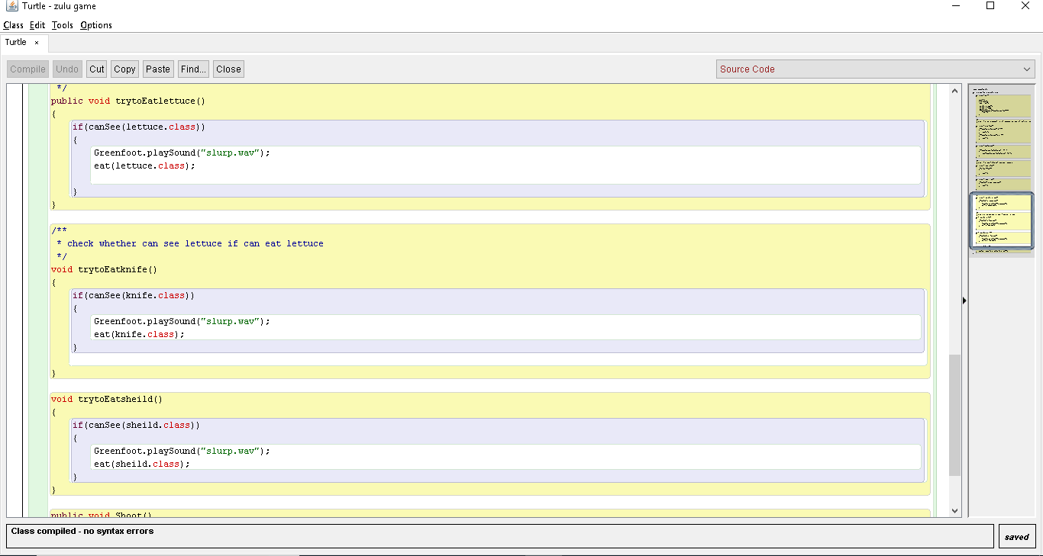

The code for collecting the collectables are in the turtle class this is where the command to eat or collect each item is placed. You can edit the image of these collectables and also the sound but the file as to be a .wav type file.

# **Obstruction**

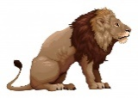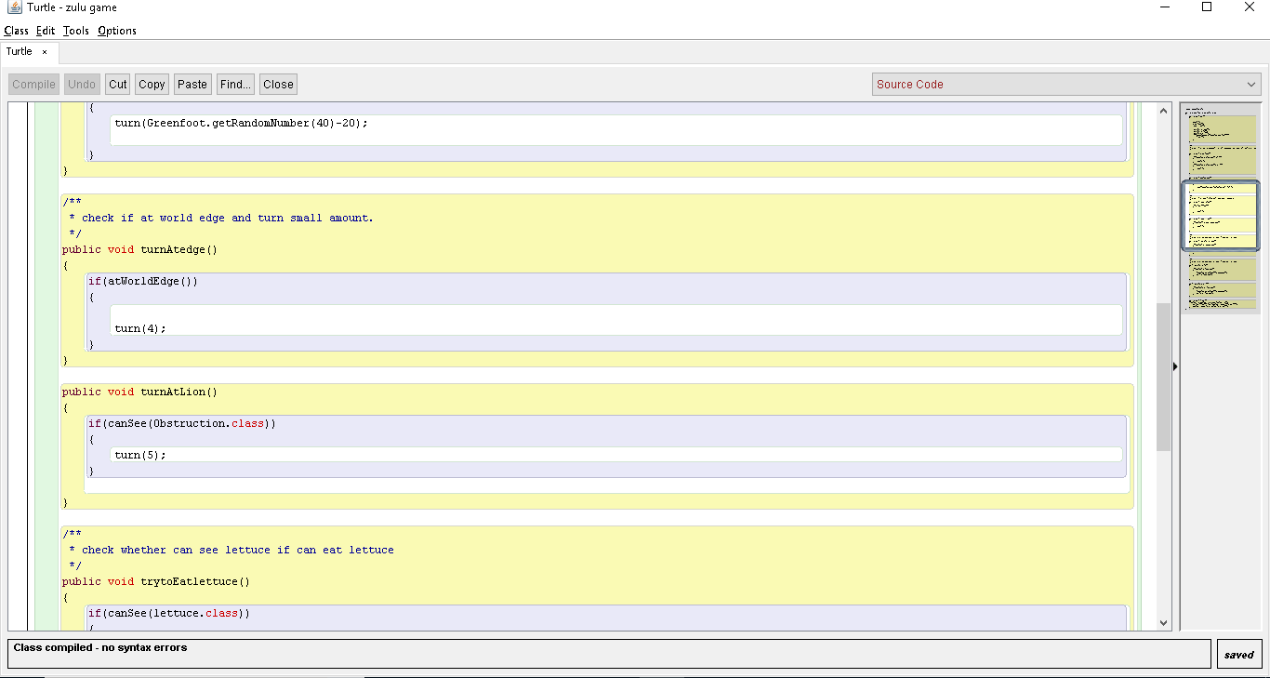

If you want to change the effect the obstruction has you would have to edit the code in the turtle class and the snake class because it affects the player and enemy. You can also change the amount of turn it does to the player to make it more challenging.

# **Screens**

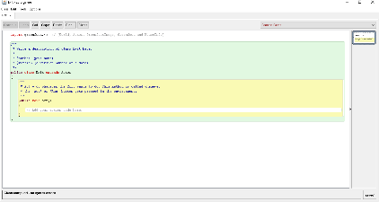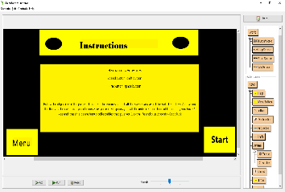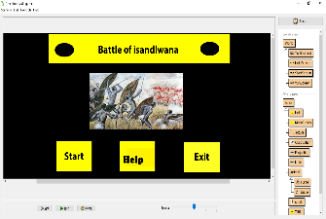

To change the code of the screen transitions you would have to operate the Start button class, help button class and exit button class. You can change the position of the buttons also and the transitions.